Cistercian College
Notification regarding the Board of Management’s review of the Child Safeguarding Statement

To:_All Staff

The Board of Management of Cistercian College wishes to inform you that:

• The Board of Management’s annual review of the school’s Child Safeguarding Statement was completed at the Board meeting of 29/04/2025.

• This review was conducted in accordance with the “Checklist for Review of the Child Safeguarding Statement” published on the gov.ie website

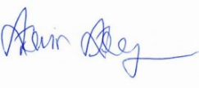
Signed Date 29/04/2025

Chairperson, Board of Management

Signed 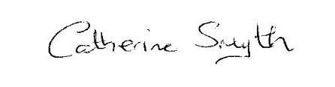 Date 29/04/2025

Principal/Secretary to the Board of Management

